Current State Architecture Flow
TrackAllLoanMaintenanceLegacy
────────────────────────────
Loan Maintenance Modernization Document Set

Table of Contents
1. Current State — System Context
2. Business Process Flows
2.1 Search Loan
2.2 Quote Process (post-search)
2.3 14E Dispatch
2.4 Add Loan
2.5 Modify Loan
3. Technical Dependency Flows
3.1 Search sequence
3.2 Add sequence
3.3 Process/Dispatch sequence
5. Integration Map
Open Items / Ambiguities
Traceability Summary / Cross-Reference

Document Governance Note
Grounding labels covered in this publication set: [SG], [SG-influenced], [inferred], [placeholder]. Review Priority badges are styled as Priority or Standard where rule-review columns appear.

Current State Architecture Flow

1. Current State — System Context
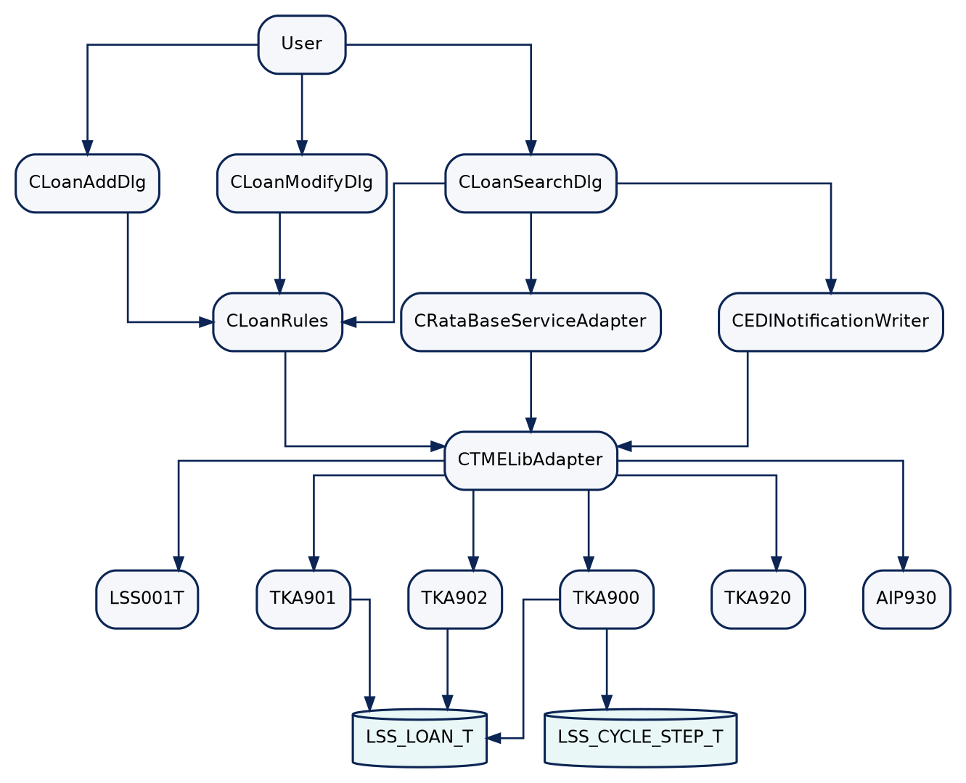
Mermaid diagram rendered from source (1)

2. Business Process Flows

2.1 Search Loan
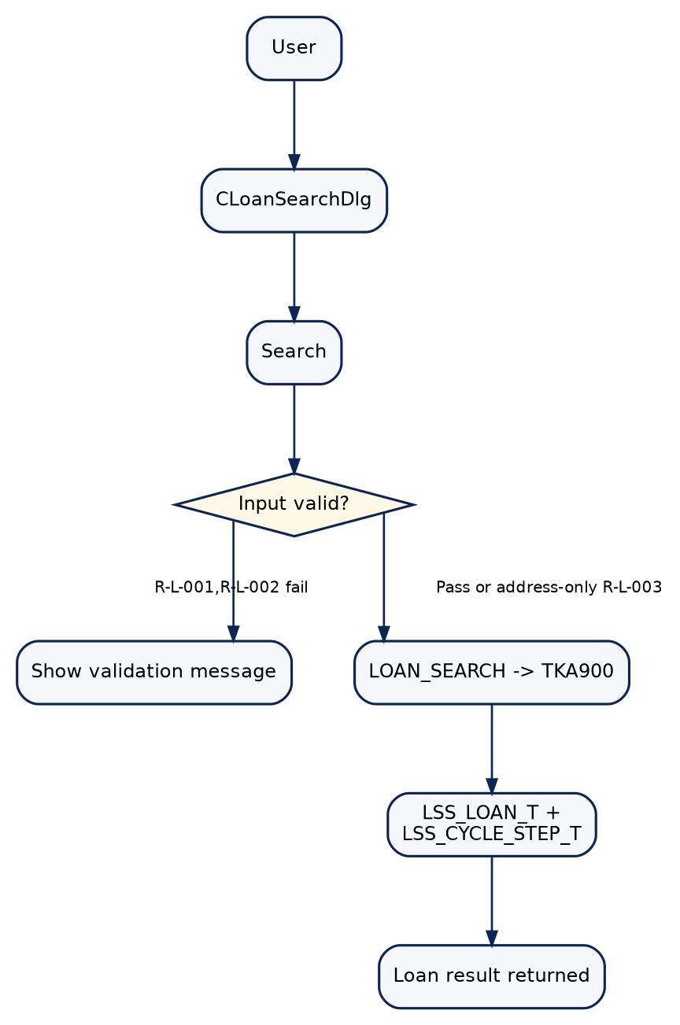
Mermaid diagram rendered from source (2)

2.2 Quote Process (post-search)
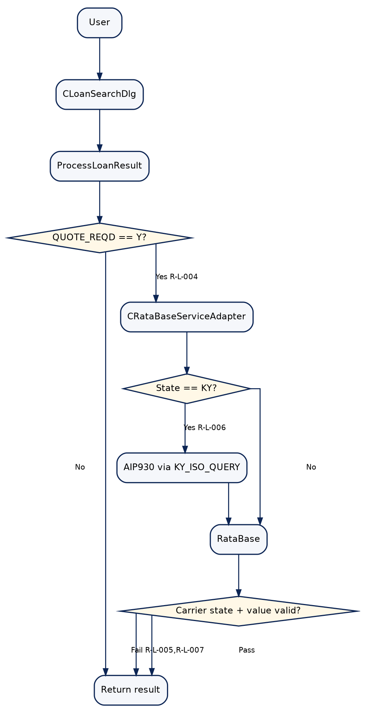
Mermaid diagram rendered from source (3)

2.3 14E Dispatch
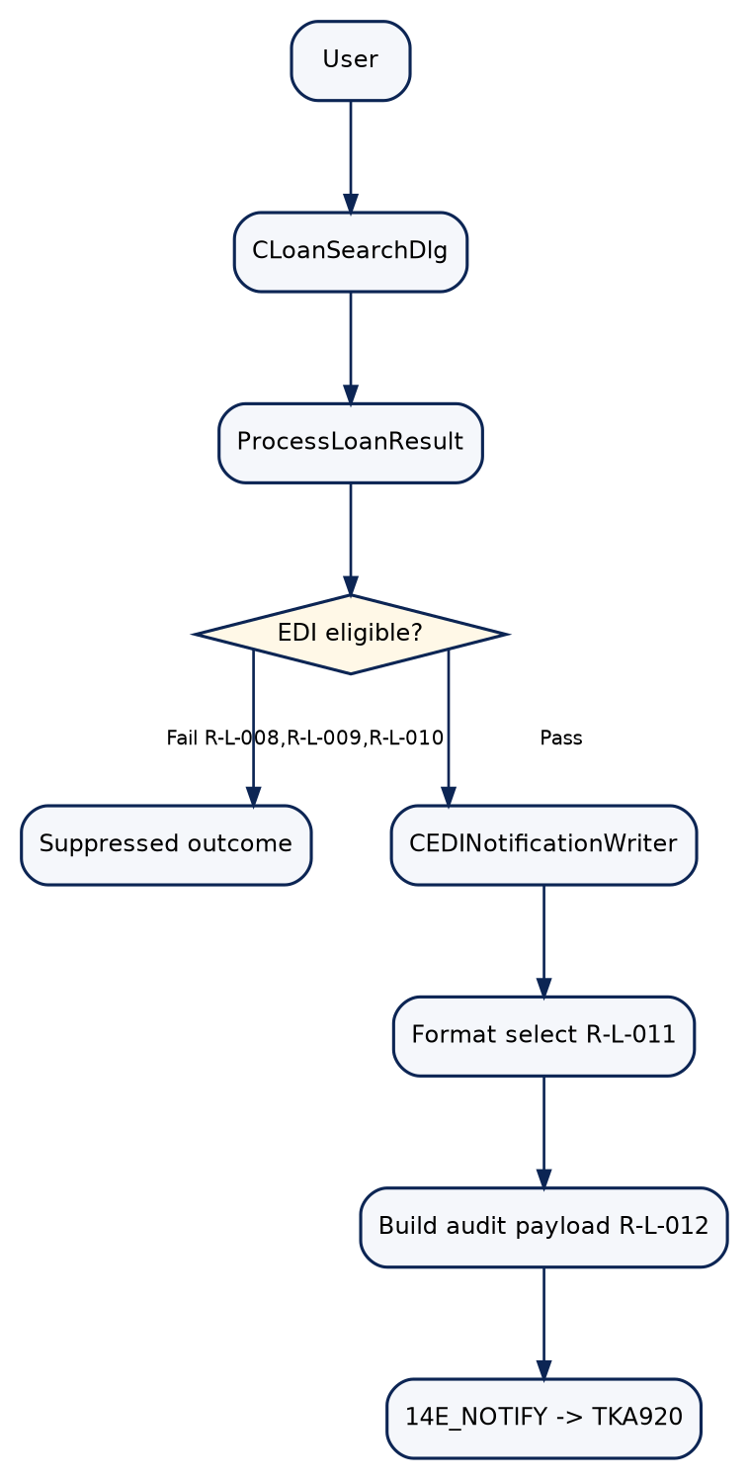
Mermaid diagram rendered from source (4)

2.4 Add Loan
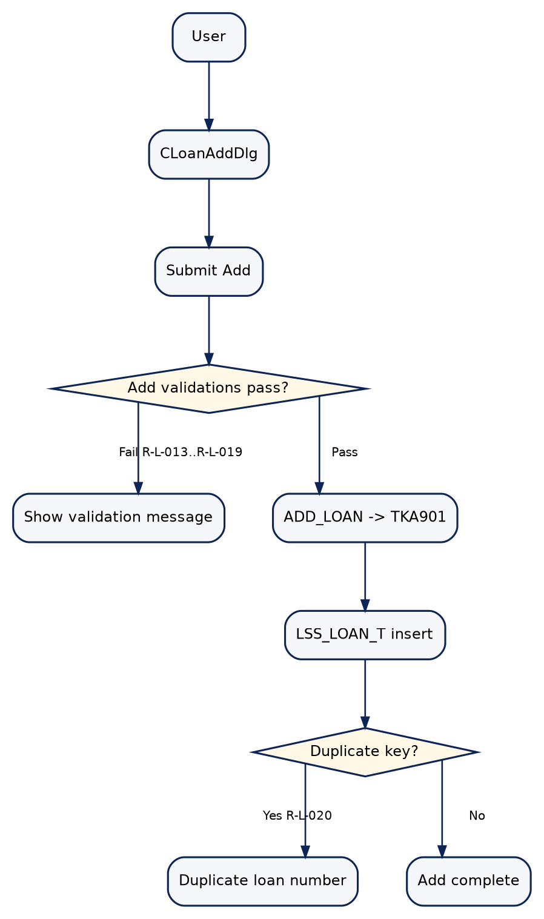
Mermaid diagram rendered from source (5)

2.5 Modify Loan
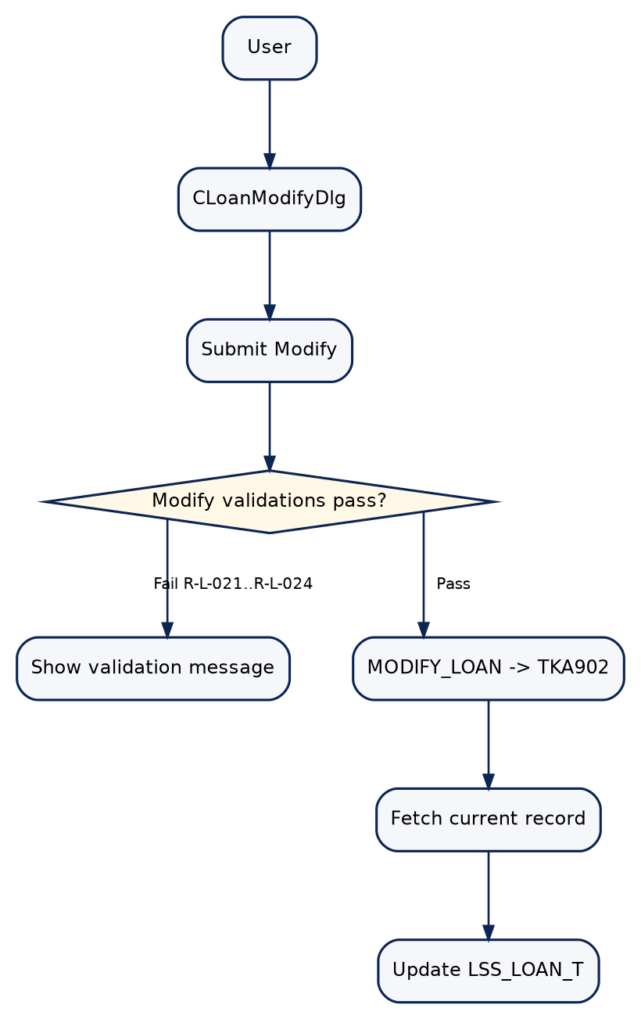
Mermaid diagram rendered from source (6)

3. Technical Dependency Flows

3.1 Search sequence
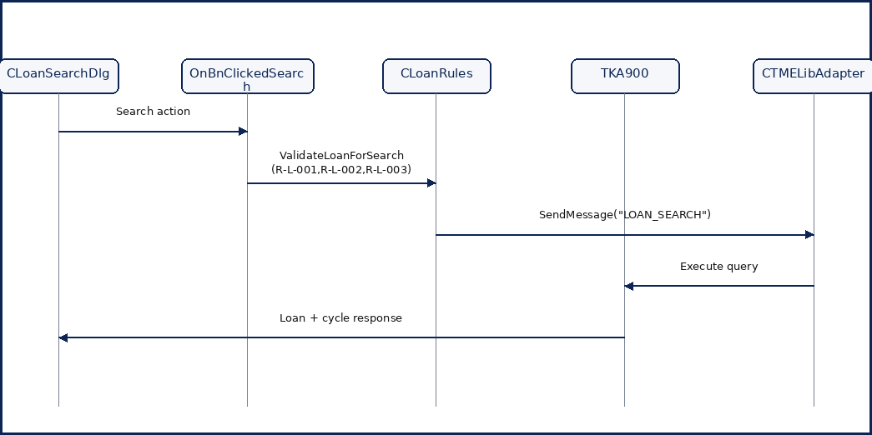
Mermaid diagram rendered from source (7)

3.2 Add sequence
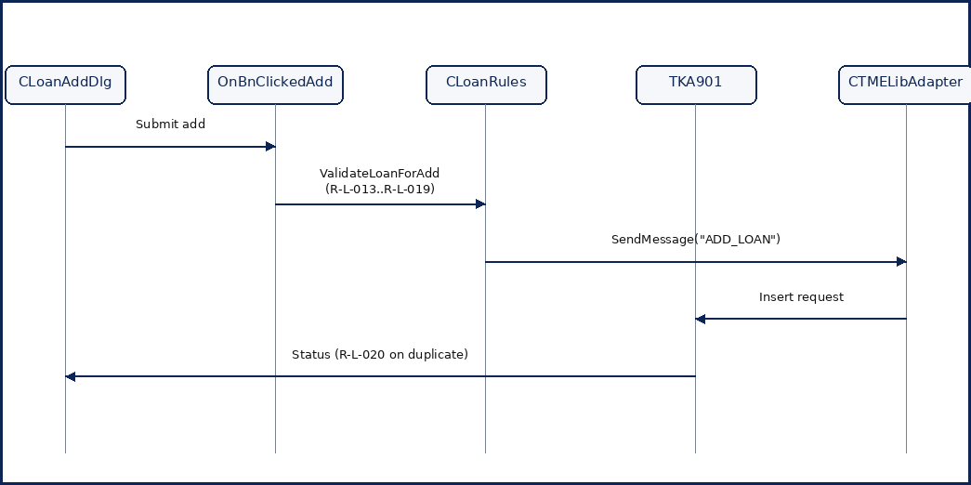
Mermaid diagram rendered from source (8)

3.3 Process/Dispatch sequence
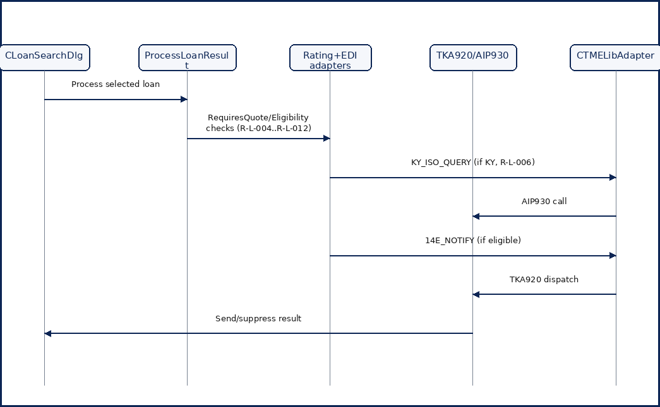
Mermaid diagram rendered from source (9)

5. Integration Map
Integration Point | Protocol | Direction | Legacy System | Evidence
LOAN_SEARCH | TME mnemonic over fgatetcp/TLS | App -> Tandem | TKA900 | TMELibAdapter.cpp::SendMessage; TKA900.cbl
ADD_LOAN | TME mnemonic over fgatetcp/TLS | App -> Tandem | TKA901 | LoanAddDlg.cpp; TKA901.cbl
MODIFY_LOAN | TME mnemonic over fgatetcp/TLS | App -> Tandem | TKA902 | LoanModifyDlg.cpp; TKA902.cbl
14E_NOTIFY | TME mnemonic over fgatetcp/TLS | App -> Tandem | TKA920 | EDINotificationWriter.cpp; TKA920.cbl
KY_ISO_QUERY | TME mnemonic over fgatetcp/TLS | App -> Tandem | AIP930 | RataBaseServiceAdapter.cpp; LSS001T seed
RataBase quote | External HTTP service call | App -> External | RataBase | RataBaseServiceAdapter.cpp::GetQuote

Diagram suggestion callout:
- Render each Mermaid diagram as a high-resolution embedded image with readable labels at print scale.
---

Open Items / Ambiguities
Unresolved items requiring SME or implementation-team validation are listed below.
ID | Open question
A-001 | Add/Modify rc templates and concrete control definitions are missing from current resource files.
A-002 | Three Loan Search control IDs are referenced in code but absent in current rc/resource definitions.
A-003 | Confirm whether "loan must exist before modification" should be promoted to a standalone rule card.
A-004 | Confirm whether selected-row precondition for opening Modify is documented as a formal business rule.
A-005 | Confirm add-handler delegation evidence treatment for rule-card references.
A-006 | Confirm modify-handler delegation evidence treatment for rule-card references.

Traceability Summary / Cross-Reference
Rule ID | Functional Area | Review Priority | Candidate API / Service | Blueprint Spec
R-L-001 | Loan Search Input Validation | Standard | POST /api/loans/search (LoanService) | UI-001 + SVC-001
R-L-002 | Loan Search Input Validation | Standard | POST /api/loans/search (LoanService) | UI-001 + SVC-001
R-L-003 | Loan Search Input Validation | Standard | POST /api/loans/search (LoanService) | UI-001 + SVC-001
R-L-004 | Premium Rating | Standard | POST /api/quotes/rating (RatingService) | UI-001 + SVC-002
R-L-005 | Premium Rating | Standard | POST /api/quotes/rating (RatingService) | SVC-002
R-L-006 | Premium Rating | Standard | POST /api/quotes/rating (RatingService) | SVC-002
R-L-007 | Premium Rating | Standard | POST /api/quotes/rating (RatingService) | SVC-002
R-L-008 | EDI Notification | Standard | POST /api/edi/notifications/14e (EdiNotificationService) | SVC-003
R-L-009 | EDI Notification | Standard | POST /api/edi/notifications/14e (EdiNotificationService) | SVC-003
R-L-010 | EDI Notification | Standard | POST /api/edi/notifications/14e (EdiNotificationService) | SVC-003
R-L-011 | EDI Notification | Standard | POST /api/edi/notifications/14e (EdiNotificationService) | SVC-003
R-L-012 | Audit Trail | Standard | POST /api/edi/notifications/14e (EdiNotificationService) | SVC-003 + DB-AUDIT
R-L-013 | Add Loan Validation | Standard | POST /api/loans (LoanService) | UI-002 + SVC-001
R-L-014 | Add Loan Validation | Standard | POST /api/loans (LoanService) | UI-002 + SVC-001
R-L-015 | Add Loan Validation | Standard | POST /api/loans (LoanService) | UI-002 + SVC-001
R-L-016 | Add Loan Validation | Standard | POST /api/loans (LoanService) | UI-002 + SVC-001
R-L-017 | Add Loan Validation | Standard | POST /api/loans (LoanService) | UI-002 + SVC-001
R-L-018 | Add Loan Validation | Standard | POST /api/loans (LoanService) | UI-002 + SVC-001
R-L-019 | Add Loan Validation | Standard | POST /api/loans (LoanService) | UI-002 + SVC-001
R-L-020 | Add Loan Validation | Standard | POST /api/loans (LoanService) | SVC-001 + DB-001
R-L-021 | Modify Loan Validation | Standard | PUT /api/loans/{loanNum} (LoanService) | UI-003 + SVC-001
R-L-022 | Modify Loan Validation | Standard | PUT /api/loans/{loanNum} (LoanService) | UI-003 + SVC-001
R-L-023 | Modify Loan Validation | Standard | PUT /api/loans/{loanNum} (LoanService) | UI-003 + SVC-001
R-L-024 | Modify Loan Validation | Standard | PUT /api/loans/{loanNum} (LoanService) | UI-003 + SVC-001
R-L-025 | Integration Gateway | Standard | Internal TandemGatewayClient | SVC-001 + SVC-003

